ACSL
American Computer Science League
2013 - 2014

All-Star

Short Round Solutions
1. (D) 1
- Boolean Algebra
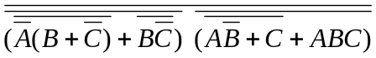=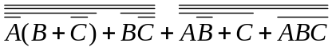
=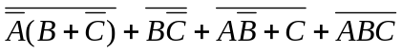=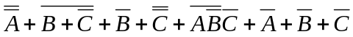 =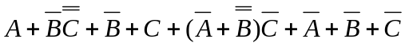=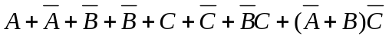 =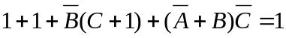

2. Digital Electronics
The digital circuit is represented by the following Boolean
expression: ~((A◊~AB◊(B+C))((B+C) CD~D))

A | B | C | D | ~D | ~AB | B+C | ◊ | CD |  | ( )( ) | ~
0 | 0 | 0 | 0 | 1 | 1 | 0 | 1 | 0 | 1 | 1 | 0
0 | 0 | 0 | 1 | 0 | 1 | 0 | 1 | 0 | 0 | 0 | 1
0 | 0 | 1 | 0 | 1 | 1 | 1 | 1 | 0 | 1 | 1 | 0
0 | 0 | 1 | 1 | 0 | 1 | 1 | 1 | 1 | 1 | 1 | 0
0 | 1 | 0 | 0 | 1 | 1 | 1 | 1 | 0 | 1 | 1 | 0
0 | 1 | 0 | 1 | 0 | 1 | 1 | 1 | 0 | 1 | 1 | 0
0 | 1 | 1 | 0 | 1 | 1 | 1 | 1 | 0 | 1 | 1 | 0
0 | 1 | 1 | 1 | 0 | 1 | 1 | 1 | 1 | 1 | 1 | 0
1 | 0 | 0 | 0 | 1 | 1 | 0 | 1 | 0 | 1 | 1 | 0
1 | 0 | 0 | 1 | 0 | 1 | 0 | 1 | 0 | 0 | 0 | 1
1 | 0 | 1 | 0 | 1 | 1 | 1 | 1 | 0 | 1 | 1 | 0
1 | 0 | 1 | 1 | 0 | 1 | 1 | 1 | 1 | 1 | 1 | 0
1 | 1 | 0 | 0 | 1 | 0 | 1 | 1 | 0 | 1 | 1 | 0
1 | 1 | 0 | 1 | 0 | 0 | 1 | 1 | 0 | 1 | 1 | 0
1 | 1 | 1 | 0 | 1 | 0 | 1 | 1 | 0 | 1 | 1 | 0
1 | 1 | 1 | 1 | 0 | 0 | 1 | 1 | 1 | 1 | 1 | 0

2. (B) 2

3. Prefix-Infix-Postfix
- + % 9 2 * & 9 ↑ + / # 9 7 4 & 4 2 / / * / * 9 # 7 5 % 7 2 8 & + 9 7 & 4
= - + % 9 2 *(& 9) ↑ + / # 9 7 4 (& 4) 2 / / * / * 9 # 7 5 % 7 2 8 & + 9 7 (& 4)
= - + (% 9 2)* 3 ↑ + / (# 9 7) 4 2 2 / / * / * 9 (# 7 5)(% 7 2) 8 & (+ 9 7) 2
= - + 4 * 3 ↑ + (/ 8 4) 2 2 / / * / (* 9 6 )3 8 (& 16) 2
= - + 4 * 3 ↑ (+ 2 2) 2 / / * (/ 54 3) 8 4 2
= - + 4 * 3 (↑ 4 2 )/ / (* 18 8)4 2 = - + 4 (* 3 16) /(/ 144 4)2
= -(+ 4 48)(/ 36 2) = - 52 18 = 34

= ( 5 5 %) 6 # 1 #
= (10 6 # ) 1 # = -4 1 # = 5

3. (C) 34

4. Computer Number Systems
11₂ = 3 In base 10 the sequence is:
11₈ = 9 3 9 27 81 ?
11011₂ = 27 3¹ 3² 3³ 3⁴ 3⁵
51₁₆ = 81 So 3⁵ = 243 = 363₈

4. (D) 363

- Bit String Flicking Let X = abcde
LHS = ( LCIRC – 2 ( 01011 OR abcde ) ) AND ( RSHIFT – 2 ( 10111
AND abcde) )
= ( LCIRC – 2 a1c11 ) AND ( RSHIFT – 2 a0cde )
= c11a1 AND 00a0c = 00a0c
RHS = ( RCIRC – 2 ( LSHIFT – 1 abcde ) )
= ( RCIRC – 2 bcde0 ) = e0bcd
So 00a0c = e0bcd ⇒ a = b, c = d = 0, d = 0, e = 0 ∴11000, 00000
5. (C) 11000, 00000

6. What Does This Program Do?

This program counts the number of decimals from 0.01, 0.02,
0.03, …, 0.99 that can be written as a reduced fraction with 100
as the denominator. There are 40 of them. 0.01, 0.03, 0.07,
0.011, …0.97, 0.99.
6. (E) None of the above

- Recursive Functions
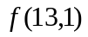 = 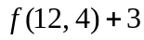 = 88 + 3 = 91
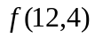 = (11,7) + 3 = 85 + 3 = 88
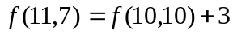= 82 + 3 = 85
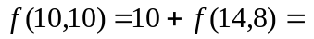10 + 72 = 82
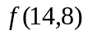= 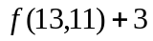= 69 + 3 = 72
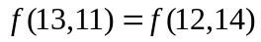+ 3 = 66 + 3 = 69
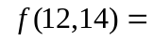2*12 + 3*14= 24 + 42 = 66 Now substitute backwards.

7. (B) 91

- Data Structures

Depth | Sum at that depth | Internal Length
1 | 1 x 2 = 2 | 2
2 | 2 x 4 = 8 | 10
3 | 3 x 8 = 24 | 34
4 | 4 x 16 = 64 | 98
5 | 5 x 32 = 160 | 258
6 | 6 x 64 = 384 | 642

8. (B) 642

- Graph Theory
The cycles from A are ADCA, ABCA.
Edge EB adds cycles ADEBCA and AEBCA.
Edge EA adds cycles ABCEA, ADCEA, ADEA, AEA.
Edge EC adds cycles ADECA, AECA.
Edge ED adds cycle AEDCA
Edge BA adds cycle ABA, ADCBA

9. (D) ED

- LISP
(CAR(CAR(REVERSE(CDR(CDR ‘(1(2 (3 4))(5 (6 7) 8 (9 (1 4)))))))))
=(CAR(CAR(REVERSE(CDR ‘((2 (3 4))(5 (6 7) 8 (9 (1 4))))))))
=(CAR(CAR(REVERSE ‘((5 (6 7) 8 (9 (1 4)))))))
=(CAR(CAR ‘((5 (6 7) 8 (9 (1 4))))))
=(CAR ‘(5 (6 7) 8 (9 (1 4)))))
= 5

10. (E) None of the above

- FSA and Regular Expressions
The FSA translates to the following regular expression:
11*0((10*(010*1 OR 110*1)01*)
OR (11*0(10*11 OR 10*0)01*))01*(111*1 OR 10*00)
Only choices a, c, d and f are accepted.

11. (D) a, c, d, f

- Assembly Language
The high level program equivalent to the program is as follows:
READ N
WHILE N <> 0 DO
TEMP1 = 2*X*X
TEMP2 = 4*X
ANS = TEMP1 – TEMP2 – 30
IF ANS = 0 THEN PRINT N
END

This program tests some numbers to see if they are solutions to 2x² – 4x – 30 = 0. The roots are -3 and 5.

12. (C) -3, 5

